Riga Technical University
Faculty of Computer Science, Information Technology and Energy

Report on the second practical assignment
Study course "Fundamentals of artificial intelligence"

Team number: 22
Students: Alizamin Aghayev – 241ADB066
Azad Turan – 231ADB256
Avemariya Perumadan Siju – 241ADB033
Batuhan Odçıkın – 260ADB027

Teaching staff: Alla Anohina-Naumeca

Project link: /link/
Link to dataset: https://www.kaggle.com/datasets/nikhil7280/weather-type-classification

2025/2026 academic year

Statement of use of AI tools
The following artificial intelligence tools were used in the development of this assignment:

ChatGPT (OpenAI, 2026, GPT-5.5, https://chatgpt.com/) was used for explaining machine learning concepts, improving report writing, analysing Orange workflow results, generating conclusions, and assisting with interpretation of clustering and classification experiments.

ChatGPT was also used for improving grammar, formatting report sections, explaining preprocessing methods, and helping analyse evaluation metrics such as CA, Precision, Recall, F1-score, MCC, and AUC.

Orange tool workflow

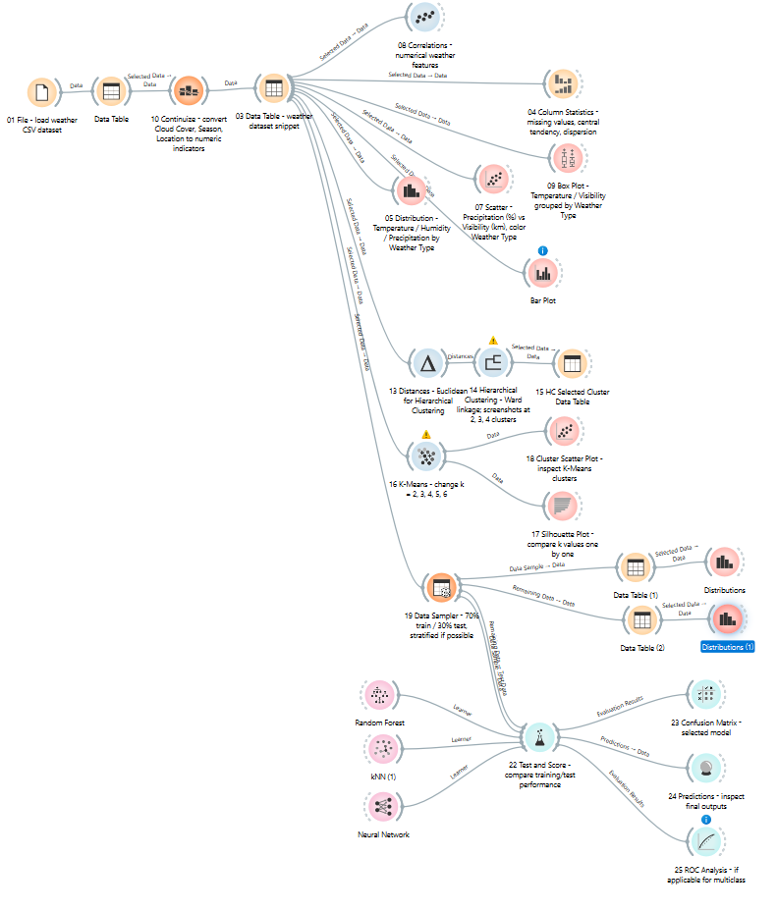

Part I

Description of the dataset

Dataset title:
Weather Type Classification

Dataset source:
https://www.kaggle.com/datasets/nikhil7280/weather-type-classification

Creator and/or owner of the dataset: The dataset was published on Kaggle by user nikhil7280.
Description of the dataset problem domain: The dataset belongs to weather classification. The goal is to predict the weather type as Sunny, Rainy, Cloudy, or Snowy using weather features such as temperature, humidity, precipitation, visibility, season, and location.
Dataset licensing conditions: The dataset is publicly available on Kaggle for educational and research use.
Information about the method or procedure for collecting the dataset:
The dataset contains structured weather observations based on meteorological features. It was prepared for machine learning classification tasks.

Description of the dataset content
Number of data objects in the dataset:
There are 13200 data objects in the dataset
Representation of features (attributes) of the dataset together with their roles in the Orange tool:
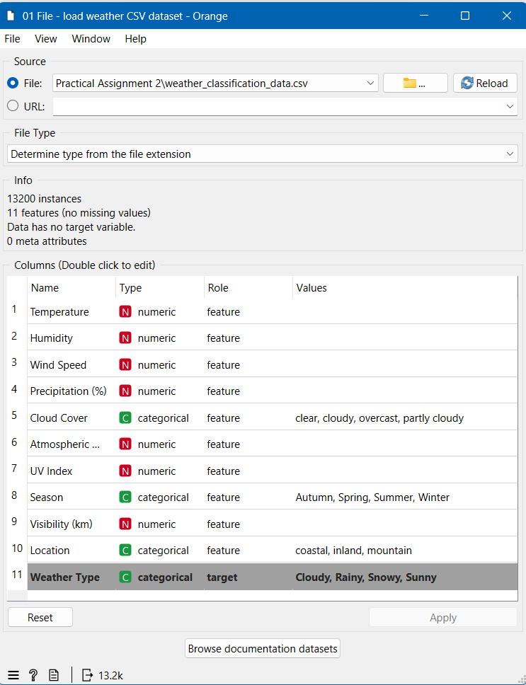

Number of classes in the dataset:
There are 4 classes in the dataset.

Description of classes:

The target variable of the dataset is Weather Type. This variable represents the general weather condition for each data object. In this assignment, the classification task is to predict the Weather Type class based on meteorological and environmental attributes such as temperature, humidity, wind speed, precipitation, cloud cover, atmospheric pressure, UV index, season, visibility, and location.

Number of data objects belonging to each class:
Class label | Number of data objects
Cloudy | 3300
Rainy | 3300
Snowy | 3300
Sunny | 3300

Description of features:
Feature title | Explanation of the feature | Value type | Range of values
Temperature | Air temperature measured for the weather condition. It is an important feature for distinguishing especially sunny and snowy weather types. | Numerical / continuous | Approximately from negative values to around 40°C
Humidity | Percentage of moisture in the air. Higher humidity values are usually associated with rainy, cloudy, or snowy weather. | Numerical / continuous | 0–100%
Wind Speed | Speed of the wind during the observed weather condition. | Numerical / continuous | Non-negative numerical values, km/h or similar unit depending on dataset definition
Precipitation (%) | Amount or probability/intensity of precipitation represented as a percentage. It is useful for separating rainy and snowy conditions from sunny conditions. | Numerical / continuous | Usually 0–100%, but the dataset may contain values above 100 as outliers
Cloud Cover | Describes the sky condition in terms of cloudiness. | Categorical / nominal | clear, partly cloudy, overcast
Atmospheric Pressure | Atmospheric pressure value measured for the weather condition. | Numerical / continuous | Approximately around 900–1050 hPa, but outliers may exist
UV Index | Ultraviolet radiation index. Higher values are generally more common in sunny conditions. | Numerical / discrete | Usually 0–11 or slightly higher
Season | Season in which the weather condition is observed. | Categorical / nominal | Spring, Summer, Autumn, Winter
Visibility (km) | Visibility distance in kilometers. Lower visibility may occur in rainy or snowy weather. | Numerical / continuous | Non-negative values, usually around 0–10 km
Location | General type of geographical location where the weather condition is observed. | Categorical / nominal | inland, mountain, coastal
Weather Type | Target/class variable representing the general weather condition to be predicted. | Categorical / nominal | Sunny, Rainy, Cloudy, Snowy

Data file structure:
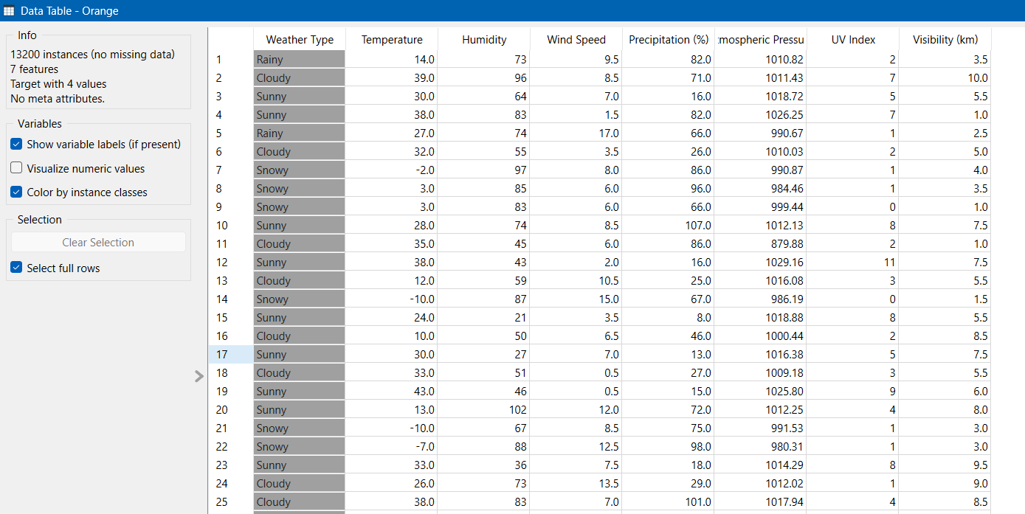
Information about missing values:
The dataset contains 13,200 data objects and 11 columns. According to the File widget in Orange, the dataset has no missing values. Therefore, no missing value imputation was required before the analysis.
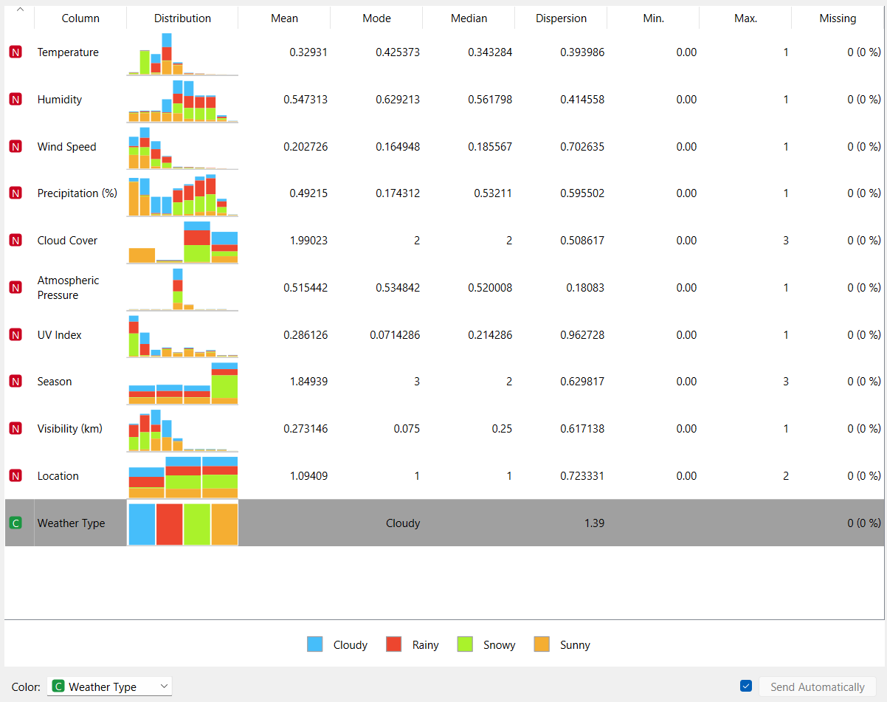
Although no missing values were detected, the dataset was still passed through preprocessing widgets to ensure that the data was suitable for later machine learning steps. The target variable Weather Type was kept as the class variable and was not converted into an input feature.

Information about outliers:
Outliers were checked using visual analysis and descriptive statistics. The Column Statistics, Box Plot, and Distributions widgets were used to inspect the numerical features such as Temperature, Humidity, Wind Speed, Precipitation (%), Atmospheric Pressure, UV Index, and Visibility (km).

Some values appear to be extreme compared with typical weather conditions. For example, Precipitation (%) may contain values above 100, and Atmospheric Pressure may contain unusually low values. These values were treated as potential outliers. However, they were not automatically removed from the dataset because the dataset may contain synthetic or extreme weather scenarios, and removing such values could eliminate meaningful examples of rare weather conditions.

Instead of removing the outliers, the numerical values were normalized to the interval [0, 1]. This reduces the influence of different numerical scales in distance-based algorithms such as K-Means, Hierarchical Clustering, and kNN.

Information about duplicated data objects:
Duplicate data objects were checked to determine whether the dataset contains completely identical rows. Duplicate records can negatively affect machine learning results because they may give excessive importance to repeated observations.

No duplicate handling operation was applied in Orange because the dataset was used as a structured classification dataset and the main focus of this assignment was feature exploration, clustering, and classification. If totally identical rows are detected, the appropriate solution would be to remove one copy of each duplicated row before model training.

Information about correlating features:
Correlations between numerical features were analysed using the Correlations widget in Orange. The purpose of this step was to identify whether some features contain highly similar information. Strongly correlated features can sometimes reduce the interpretability of the model or give repeated importance to the same type of information.

The correlation analysis focused on numerical variables such as Temperature, Humidity, Wind Speed, Precipitation (%), Atmospheric Pressure, UV Index, and Visibility (km). If strong correlations are observed, they should be discussed in relation to the meaning of the features. For example, Temperature and UV Index may be positively related, while Precipitation (%) and Visibility (km) may be negatively related.

In this assignment, correlated features were not removed automatically. The reason is that the features represent different meteorological measurements, and even correlated weather attributes may still provide useful information for distinguishing between Sunny, Rainy, Cloudy, and Snowy classes. Therefore, all selected features were kept for further analysis.

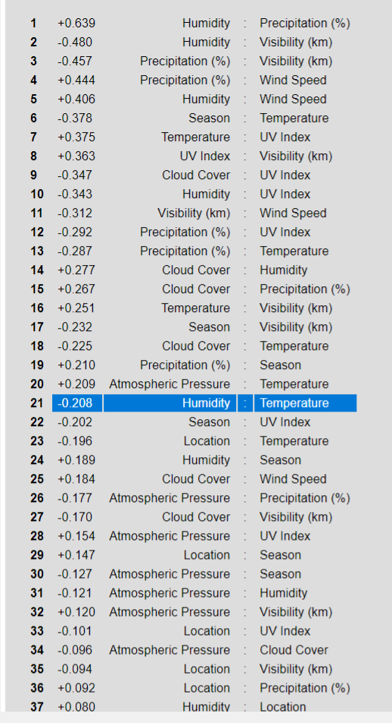
Figure 1 Correlation Analysis Result

Information about the necessity to normalize feature values:
Feature normalization was necessary because the dataset contains numerical attributes with different value ranges. For example, Humidity is represented as a percentage, Atmospheric Pressure has values around hundreds or thousands, UV Index has a much smaller range, and Visibility is measured in kilometres. If these values are used directly, features with larger numerical ranges may dominate distance-based algorithms.

Normalization is especially important for K-Means, Hierarchical Clustering, kNN, and Neural Network models because these algorithms are sensitive to the scale of input features. Therefore, numerical features were normalized to the interval [0, 1] using the Continuize widget in Orange.

In addition, categorical features such as Cloud Cover, Season, and Location were converted into numerical indicators using one-hot encoding. This made the dataset suitable for clustering and supervised machine learning algorithms.

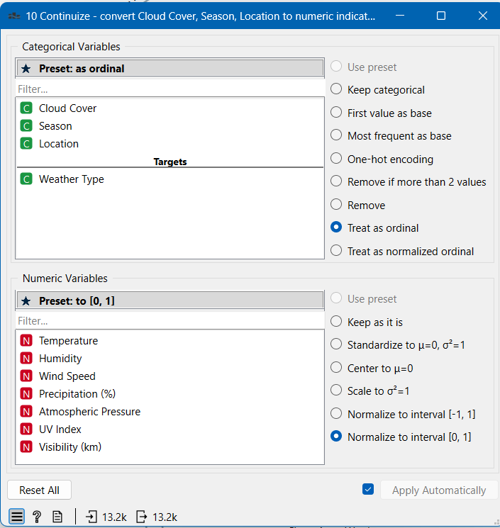
Figure 2 Normalization tool

Visual and statistical representation of the dataset
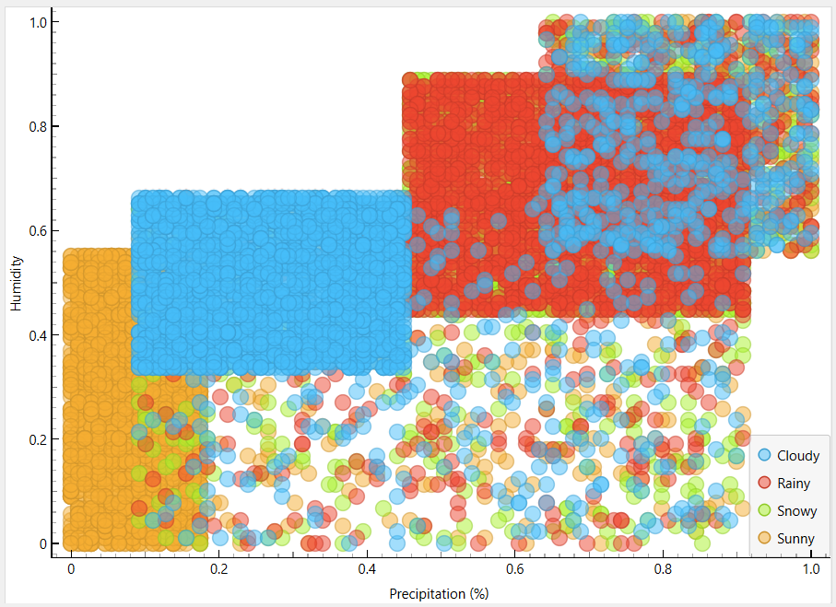
Figure 3 Scatter plot of Humidity and Precipitation (%) coloured by Weather Type

This scatter plot shows a positive relationship between humidity and precipitation. Rainy and snowy weather types tend to appear in regions with higher humidity and higher precipitation, while sunny samples are more common in lower precipitation areas. However, some overlap remains between cloudy and rainy samples.

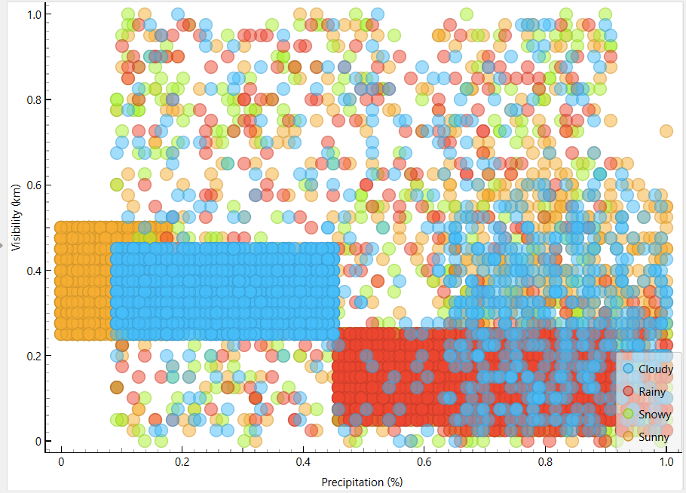
Figure 4 Scatter plot of Visibility (km) and Precipitation (%) coloured by Weather Type.

The plot shows that higher precipitation is generally associated with lower visibility. Rainy and snowy samples are more frequent in high-precipitation and low-visibility regions. Sunny samples tend to have lower precipitation and higher visibility. This indicates partial class separability, but cloudy and rainy classes still overlap.

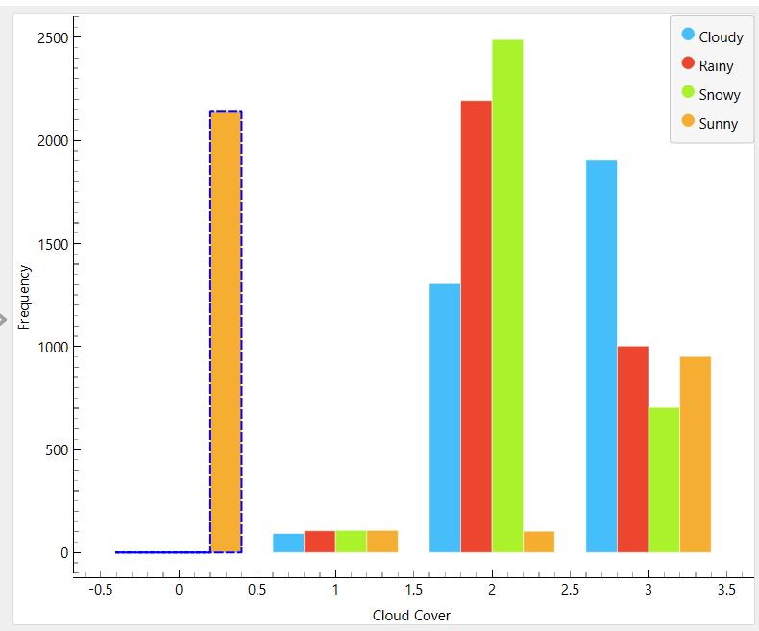
Figure 5 Distribution of Cloud Cover grouped by Weather Type.
The bar plot shows that cloud cover is strongly related to weather type. Clear sky conditions are mostly associated with sunny weather, while overcast and cloudy conditions are more common in cloudy, rainy, and snowy classes.

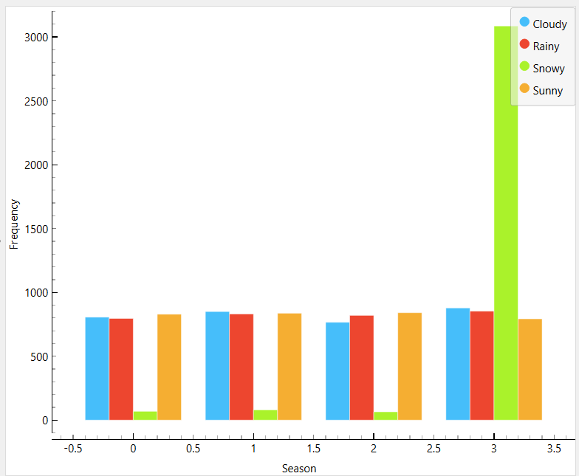
Figure 6 Distribution of Season grouped by Weather Type.
The bar plot shows how weather types are distributed across seasons. Snowy samples are expected to appear mainly in winter, while sunny and cloudy samples may be distributed across several seasons. This helps evaluate whether season contributes to class separability.

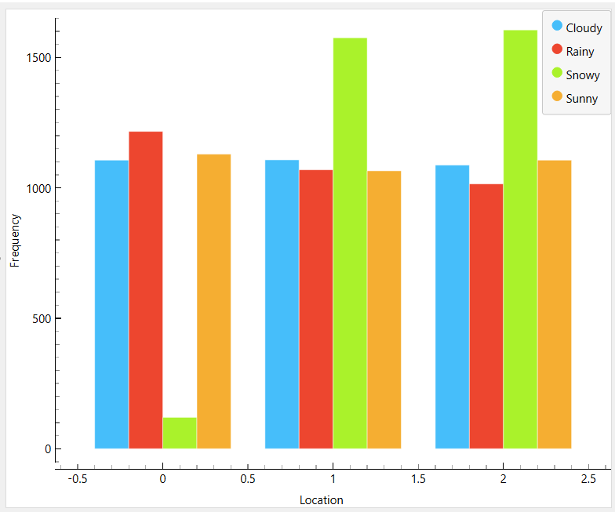
Figure 7 Distribution of Location grouped by Weather Type.
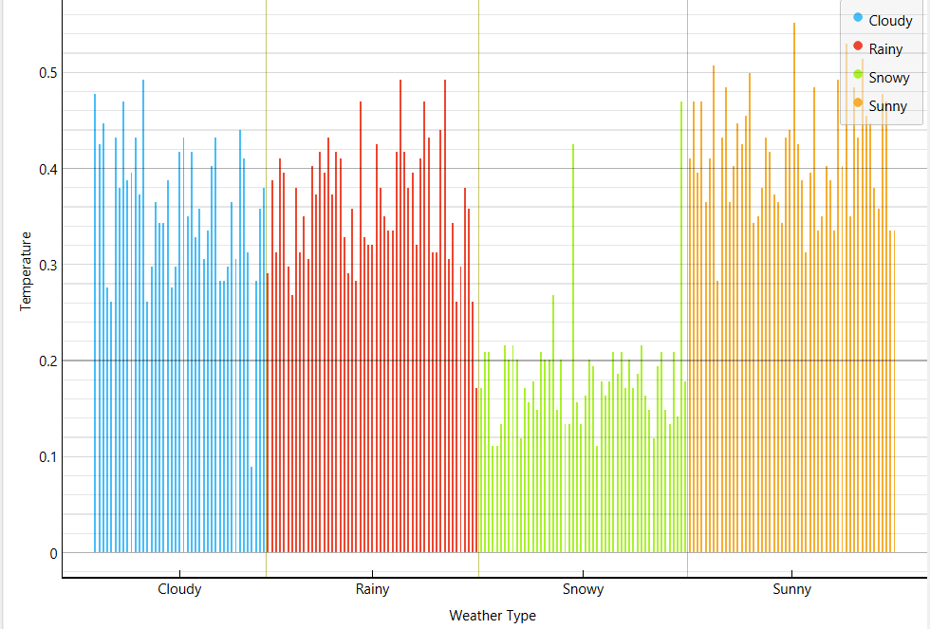
Figure 8 Histogram of Temperature grouped by Weather Type.
The temperature distribution shows that snowy samples are concentrated at lower temperature values, while sunny samples tend to appear at higher temperatures. This makes temperature one of the useful features for distinguishing weather classes.

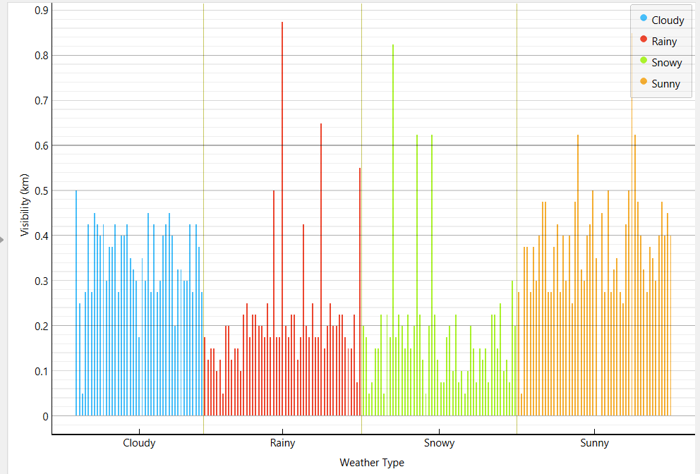
Figure 9 Histogram of Visibility (km) grouped by Weather Type.
The visibility distribution shows that rainy and snowy samples often have lower visibility, while sunny samples usually have higher visibility. However, some overlap between cloudy, rainy, and snowy conditions indicates that the classes are not perfectly separable using this feature alone.

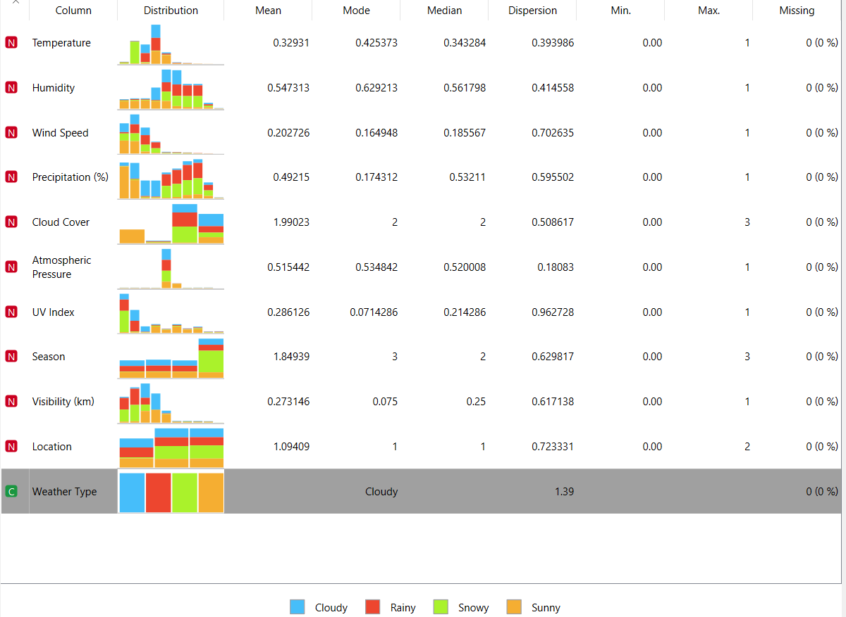
Figure 10 Column statistics of numerical weather features.

Answers to questions

Are the classes in the dataset balanced, or does one class (or several classes) prevail?

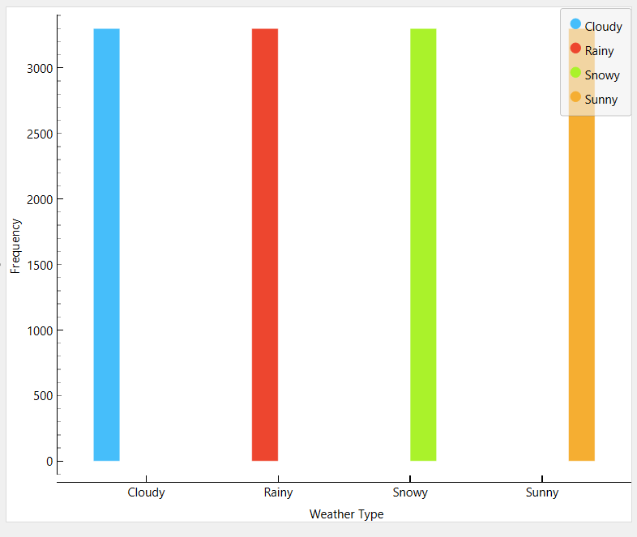
Figure 11. Distrubition of diferent classes
The classes are balanced. Each class, Cloudy, Rainy, Snowy, and Sunny, contains exactly 3300 data objects. Therefore, no class dominates the dataset.

Does the visual representation of the data allow you to see the structure of the data?
Yes, the visual representation allows the structure of the data to be observed. Scatter plots, histograms, and feature distributions show visible differences between weather classes. Sunny and Snowy classes are easier to distinguish using features such as Temperature, Visibility, and Precipitation. However, Cloudy and Rainy classes partially overlap because they share similar humidity and cloud cover characteristics.

How many data groupings can be identified by studying the visual representation of the data?

1. Sunny-like group: lower precipitation, higher visibility, often higher UV index.
2. Rainy/Snowy-like group: higher precipitation, lower visibility, higher humidity.
3. Cloudy-like group: intermediate values, often overlapping with rainy and sunny samples.
4. Snowy subgroup: lower temperature values, often separated more clearly in temperature-related plots.

Are the identified data groupings close to each other or far from each other?
The identified data groupings are relatively close to each other rather than clearly far apart. Some classes, such as Sunny and Snowy, can be separated more easily when using features such as temperature, precipitation and visibility. However, Cloudy and Rainy samples are often close to each other because they may share similar humidity, cloud cover and precipitation values. This indicates that the dataset has partial class separability, but the class boundaries are not completely clear.

Conclusions arising from the analysis of statistical indicators
The statistical analysis shows that Temperature, Precipitation, Humidity, Visibility, and UV Index are among the most important features for distinguishing weather classes. Snowy weather is generally associated with lower temperatures and lower visibility, while Sunny weather usually has higher temperatures, higher UV index values, and lower precipitation. Rainy weather often has higher humidity and precipitation values. Cloudy and Rainy classes share several similar characteristics, which explains the overlap observed in some visualizations.

Conclusions on selected features
All selected features were used in further analysis because each feature provides useful meteorological information related to weather classification. Numerical features such as Temperature, Humidity, Precipitation, Visibility, and UV Index contribute to distinguishing weather conditions, while categorical features such as Season, Cloud Cover, and Location provide additional contextual information.

Part II

Hierarchical clustering

Hyperparameters available in the Orange tool:
Hyperparameter | Description
Distance metric | Determines how the distance between data objects is calculated before hierarchical clustering. In this workflow, Eucledean distance was used because the numerical features were normalized before clustering.
Linkage method | Determines how the distance between two clusters is calculated. Ward linkage was used because it tends to create compact clusters by minimizing the increase in within-cluster variance.
Annotation | Determines which variable is displayed as labels on the dendrogram. Weather Type was used to observe how the known classes are distributed inside the clusters.
Color by | Determines how the dendrogram branches or labels are colored. Weather Type was selected to visually compare clusters with the known class labels.
Selection / cut-off line | Determines where the dendrogram is cut and how many clusters are selected. In this study, the cut-off was changed to obtain 2, 3 and 4 clusters.
Pruning / Max depth | Controls how much of the dendrogram is displayed. It helps simplify the visualization when the dataset is large. It does not change the underlying data, but it affects how much detail is shown in the dendrogram.

Description of experiments

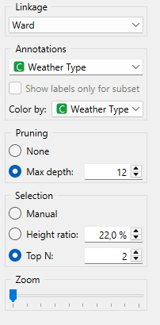
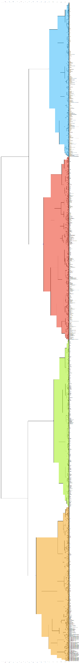
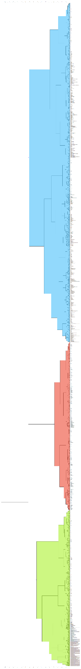
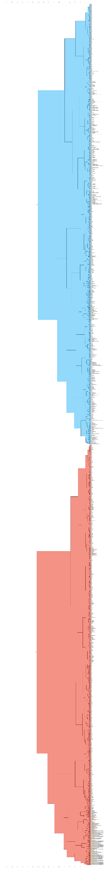
Figure 12 Hierarchical Clustering 2 clusters
Figure 13 Hierarchical Clustering 2 clusters
Figure 14 Hierarchical Clustering 2 clusters

Conclusions from experiments:
The hierarchical clustering experiments show that the number and structure of clusters change depending on the position of the horizontal cut-off line. When the cut-off line is placed higher, fewer large clusters are formed. When the cut-off line is moved lower, the dataset is divided into a greater number of smaller clusters.

With 2 clusters, the data is separated into broad weather-related groups, but the actual weather classes are not fully distinguishable. With 3 clusters, the structure becomes more meaningful because some Sunny and Snowy samples become easier to separate. With 4 clusters, the clustering structure becomes more detailed and partially resembles the four real weather classes.

However, complete separation is not achieved because Cloudy and Rainy weather conditions share similar characteristics such as humidity, precipitation, and cloud cover. Therefore, hierarchical clustering demonstrates partial class separability but not perfect separation.

K-means algorithm

Hyperparameters available in the Orange tool:
Hyperparameter | Description
Number of clusters (k) | Determines how many clusters K-Means will create. In this experiment, the range was set from k = 2 to k = 8.
Normalize columns | Scales numerical features before clustering. This is important because K-Means is distance-based and features with larger numerical ranges can dominate the result.
Initialization | Determines how the initial cluster centers are selected. KMeans++ was used because it usually gives better initial centers than random initialization.
Re-runs | Number of times the algorithm is repeated with different initializations. The best result is selected. In this experiment, it was set to 30.
Maximum iterations | Maximum number of update steps allowed for K-Means before stopping. In this experiment, it was set to 300.
Silhouette score | Evaluation measure used to estimate clustering quality. Higher values indicate better separated and more compact clusters.

Description of experiments
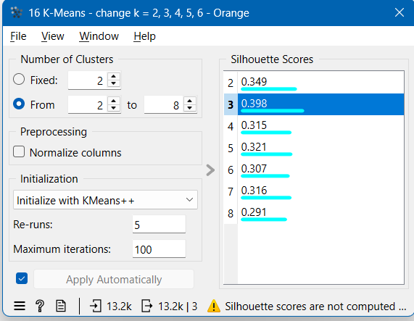
Figure 15 Silhouette scores for K-Means experiments with k values from 2 to 8.
Best result acquired with k=3.

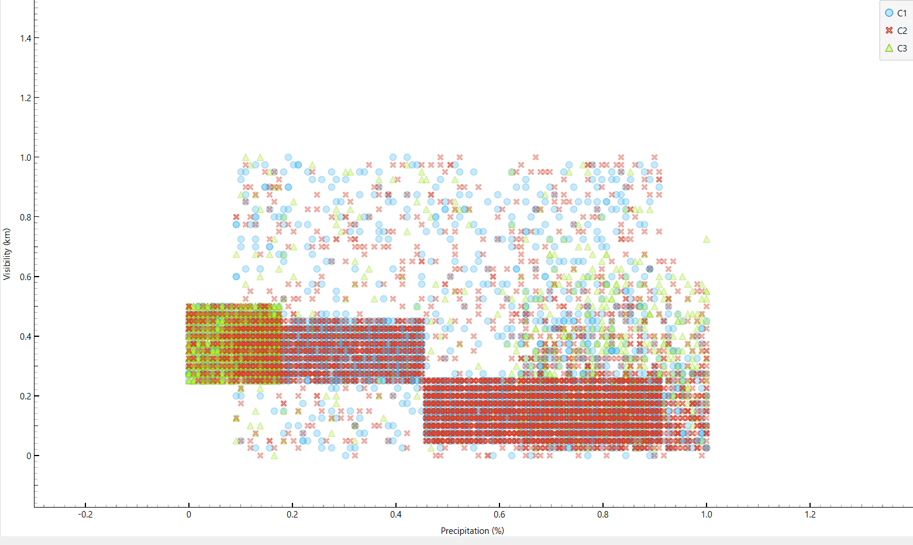
Figure 16 Scatter plot of K-Means clustering result for the best k value, k = 3.

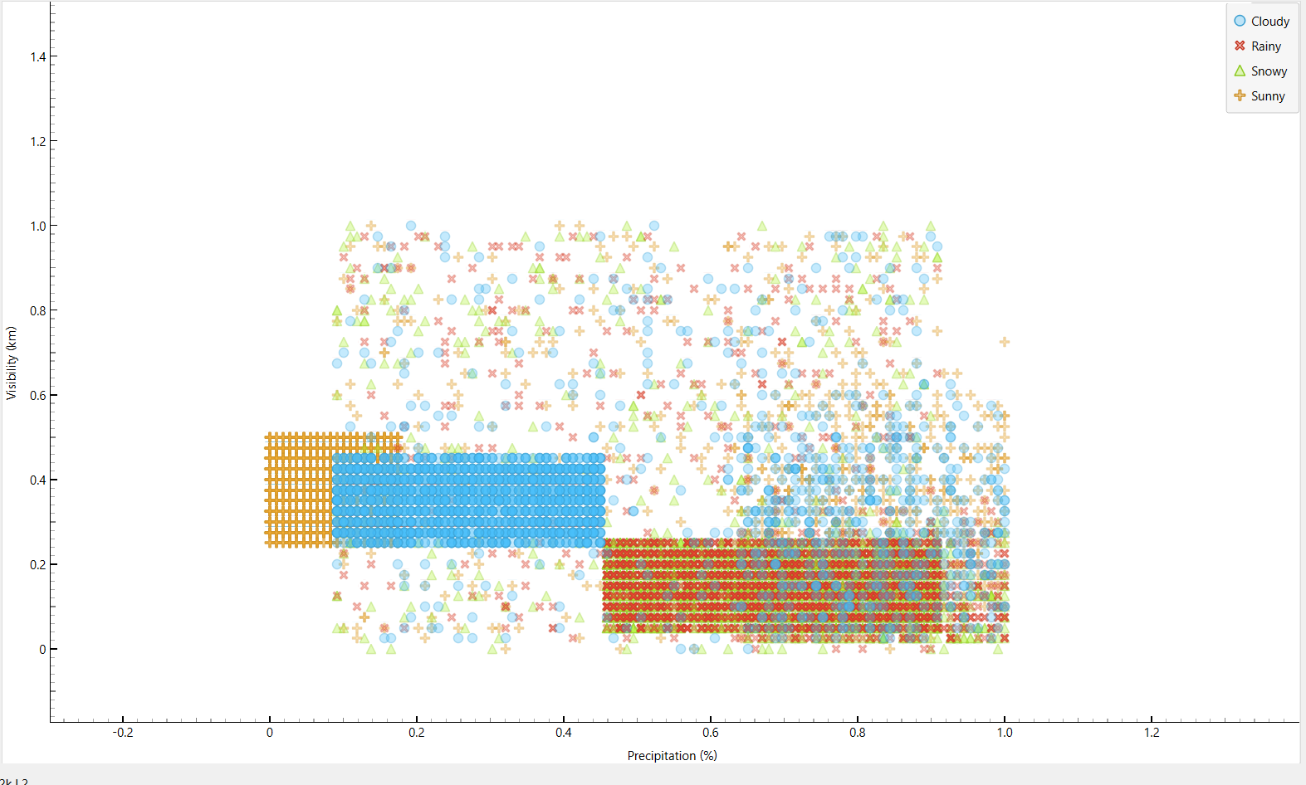
Figure 17 Scatter plot of Weather type class

Conclusions from experiments:
The K-Means experiments show that clustering quality changes depending on the selected k value. According to the Silhouette scores, the best clustering result was achieved with k = 3. This indicates that the dataset naturally forms three strong groups, even though the real target variable contains four weather classes.

The scatter plots show that Sunny and Snowy samples are more clearly separated because they differ strongly in temperature, visibility, and precipitation values. However, Cloudy and Rainy samples overlap significantly because they share similar humidity and cloud cover characteristics.

The clustering results demonstrate that the dataset contains meaningful structures and patterns, but the weather classes are not completely separable using unsupervised learning methods alone.

Final conclusions
The results of Hierarchical Clustering and K-Means show that the weather classes are partially separable. Sunny and Snowy classes can be distinguished more clearly because they have larger differences in temperature, precipitation, visibility, and UV index values. However, Cloudy and Rainy classes overlap considerably because they share similar environmental conditions.

K-Means achieved the best clustering quality with k = 3 according to the Silhouette score, while Hierarchical Clustering produced meaningful cluster structures when different cut-off lines were applied. Overall, the dataset contains visible patterns and groupings, but the classes are not perfectly separable using unsupervised learning methods.

Part III

Description of the selected algorithms

Three supervised machine learning algorithms were selected for this assignment: Artificial Neural Network, k-Nearest Neighbors (kNN), and Random Forest. These algorithms were chosen because they represent different machine learning approaches and are suitable for multi-class classification tasks.

Artificial Neural Networks are effective for learning complex non-linear relationships between features. kNN is a simple distance-based classification method that performs well on normalized datasets. Random Forest is an ensemble learning algorithm that combines multiple decision trees and usually provides strong classification performance while reducing overfitting.

Title of the first algorithm: Artificial Neural Networks

Description of the first algorithm:

Artificial Neural Networks are supervised learning models that consist of connected layers of artificial neurons. In classification tasks, the model receives feature values as input and produces a predicted class as output. During training, the network adjusts its internal weights to reduce the difference between predicted and actual class labels.

Title of the second algorithm: kNN

Description of the second algorithm:

k-Nearest Neighbors is a supervised classification algorithm based on distance and similarity. When a new data object is classified, the algorithm finds the nearest training examples and assigns a class according to their labels.

Title of the third algorithm: Random Forest

Description of the third algorithm:
Random Forest is an ensemble learning algorithm that builds multiple decision trees and combines their predictions. In classification tasks, the final class is usually selected by majority voting among the trees.

Description of hyperparameters
Hyperparameter | Description and values
Artificial Neural Networks
Neurons in hidden layers | Defines the number of neurons in the hidden layer(s). More neurons may allow the model to learn more complex patterns, but too many neurons may cause overfitting. Example values: 50, 100, 150.
Activation function | Defines how the neuron output is transformed. It helps the network learn non-linear relationships. Common values include ReLU, logistic, and tanh depending on the Orange widget options.
Solver | Defines the optimization method used to update the network weights during training. Example values may include Adam, SGD, or L-BFGS depending on the Orange version.
Max iterations | Defines the maximum number of training iterations. A higher value gives the model more time to learn, but may increase training time. Example values: 200, 500, 1000.
Regularization / Alpha | Controls model complexity and helps reduce overfitting. A higher value applies stronger regularization.
kNN
Number of neighbors | Defines how many nearest training examples are used for classification. Small values make the model more sensitive to local patterns, while larger values make it smoother. Example values: 3, 5, 7, 9.
Metric | Defines the distance measure used to compare data objects. Common values include Euclidean, Manhattan, and Chebyshev distance.
Weighting | Defines whether all neighbors have equal influence or closer neighbors have stronger influence. Example values: uniform weighting or distance weighting.
Random Forest
Number of trees | Defines how many decision trees are created in the forest. A higher number of trees usually improves stability and accuracy, but also increases computation time.
Split subset limit | Defines how many features are randomly considered when looking for the best split in each tree. This helps make the trees different from each other and reduces overfitting.
Max depth | Defines the maximum depth of each tree. A deeper tree can learn more complex patterns, but it may also overfit the training data.

Information about test and training datasets
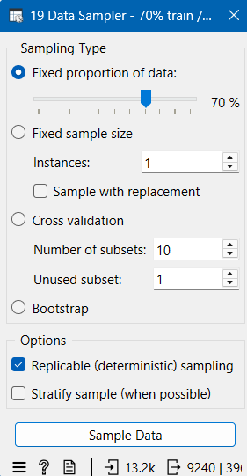
The dataset was divided into training and testing subsets using a 70% / 30% split ratio. The training dataset was used to train the machine learning models, while the testing dataset was used to evaluate the final model performance on unseen data.

Because the dataset is balanced, the class distribution remained equal in both the training and testing subsets.

Number of data objects in the training dataset: 9296

% proportion of data objects in the training dataset: 70%

Class label | Number of data objects in the training dataset | % proportion of data objects in the training dataset
Cloudy | 2324 | 25%
Rainy | 2324 | 25%
Snowy | 2324 | 25%
Sunny | 2324 | 25%

Number of data objects in the test dataset: 3904

% proportion of data objects in the test dataset: 30%

Class label | Number of data objects in the test dataset | % proportion of data objects in the test dataset
Cloudy | 976 | 25%
Rainy | 976 | 25%
Snowy | 976 | 25%
Sunny | 976 | 25%

Experiments with artificial neural network
Experiment | Hyperparameter values
Experiment 1 | Layers: 100  Activation: ReLu  Solver: Adam  Regularization a=0.1  Max iteration: 200
Experiment 2 | Layers: 20  Activation: ReLu  Solver: Adam  Regularization a=0.1  Max iteration: 200
Experiment 3 | Layers: 100  Activation: ReLu  Solver: Adam  Regularization a=0.001  Max iteration: 200

Experiment 1
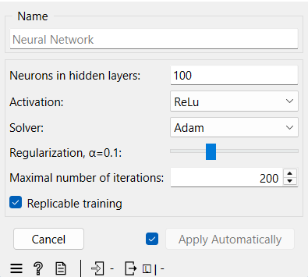
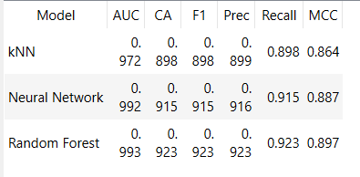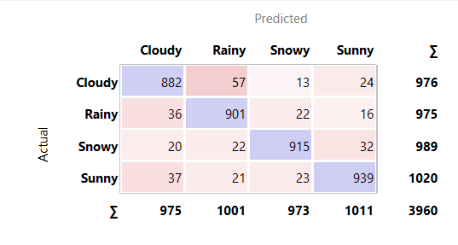

Experiment 2
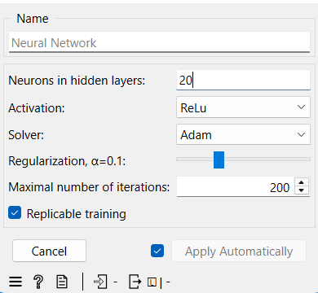
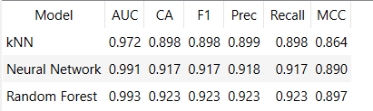
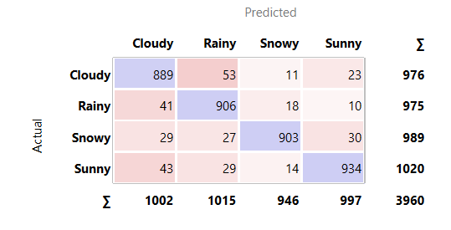

Experiment 3
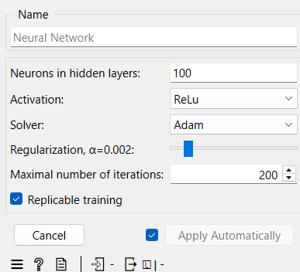
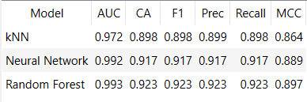
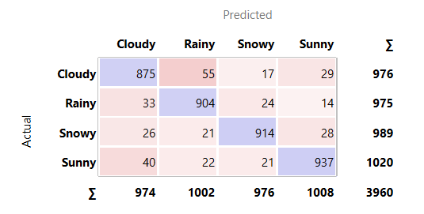3

Conclusions from experiments:

The artificial neural network experiments show that changing the number of hidden neurons and the regularization value affects the model performance. In Experiment 1, the model used 100 hidden neurons and regularization value a = 0.1. It achieved good results, with approximately CA = 0.915, F1 = 0.915, and MCC = 0.887. However, its performance was slightly lower than the other two neural network experiments.
In Experiment 2, the number of hidden neurons was reduced to 20 while the regularization value remained a = 0.1. This model achieved the best neural network results, with approximately CA = 0.917, F1 = 0.917, Precision = 0.918, Recall = 0.917, and MCC = 0.890. The confusion matrix also shows strong correct classification values for all classes.
In Experiment 3, the model used 100 hidden neurons with a lower regularization value. Its results were very close to Experiment 2, with CA = 0.917 and F1 = 0.917, but its Precision and MCC values were slightly lower than Experiment 2.
Overall, all three neural network models performed well, but Experiment 2 gave the best overall neural network performance. It achieved the highest precision and MCC value among the neural network experiments, while keeping the model simpler with fewer hidden neurons.

Model selected for testing:
The model selected for testing is Experiment 2.
It was selected because it achieved the best overall neural network performance among the experiments. Its hyperparameters are:

Hyperparameter | Value
Layers | 20
Activation | ReLu
Solver | Adam
Regularization a | 0.1
Max iteration | 200

Experiment 2 was chosen because it provided the best balance between accuracy, F1 score, precision, recall, and MCC. Although Experiment 3 had very similar results, Experiment 2 had a slightly better overall performance and used a simpler network structure.

Experiments with kNN
Experiment | Hyperparameter values
Experiment 1 | Number of Neighbors: 5  Metric: Eucledian  Weight: Uniform
Experiment 2 | Number of Neighbors: 3  Metric: Eucledian  Weight: Uniform
Experiment 3 | Number of Neighbors: 10  Metric: Eucledian  Weight: Uniform

Experiment 1
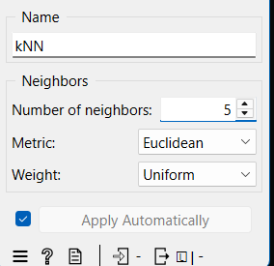

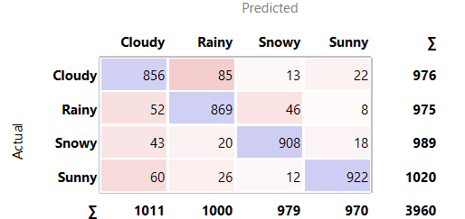

Experiment 2
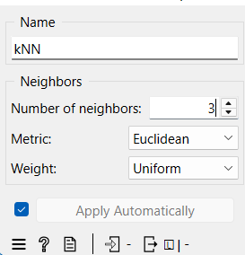

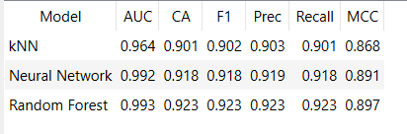

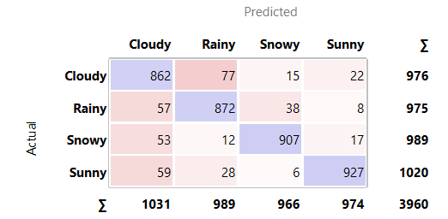
Experiment 3
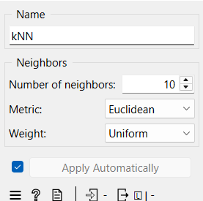

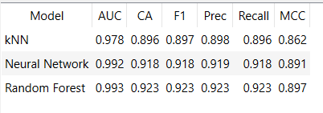

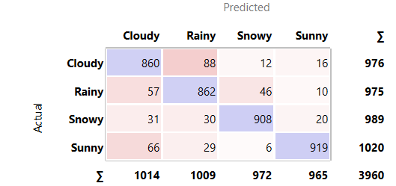

Conclusions from experiments:

The kNN experiments show that the number of neighbors affects the classification performance. In all experiments, the Euclidean distance metric and uniform weighting were used, while the number of neighbors was changed.

In Experiment 1, the model used 5 neighbors. It achieved CA = 0.898, F1 = 0.898, Precision = 0.899, Recall = 0.898, and MCC = 0.864. The confusion matrix shows that the model classified many samples correctly, but there were still some misclassifications, especially between Cloudy and Rainy classes.

In Experiment 2, the number of neighbors was reduced to 3. This experiment achieved the best kNN performance, with CA = 0.901, F1 = 0.902, Precision = 0.903, Recall = 0.901, and MCC = 0.868. Compared with the other kNN experiments, this model gave slightly better overall classification results.

In Experiment 3, the number of neighbors was increased to 10. The performance slightly decreased, with CA = 0.896, F1 = 0.897, Precision = 0.898, Recall = 0.896, and MCC = 0.862. This shows that using too many neighbors may make the model less sensitive to local patterns in the dataset.

Overall, Experiment 2 performed the best among the kNN models. The results show that using 3 neighbors provided the best balance between accuracy, F1 score, precision, recall, and MCC.

Model selected for testing:

The model selected for testing is kNN Experiment 2.

It was selected because it achieved the best overall kNN performance among the three experiments.
Hyperparameter | Value
Number of neighbors | 3
Metric | Euclidean
Weight | Uniform

Experiment 2 was chosen because it had the highest CA, F1, Precision, Recall, and MCC values among the kNN experiments.

Experiments with Random Forest
Experiment | Hyperparameter values
Experiment 1 | Number of Tree: 10  Max depth: no limit  Subset split limit: 5
Experiment 2 | Number of Tree: 20  Max depth: no limit  Subset split limit: 5
Experiment 3 | Number of Tree: 20  Max depth: no limit  Subset split limit: no limit

Experiment 1
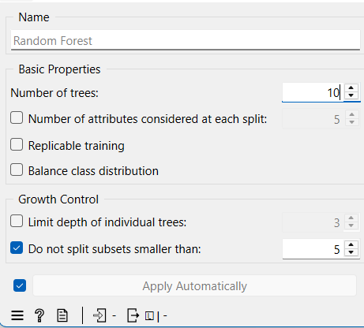
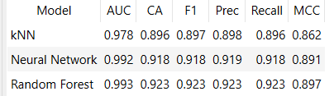
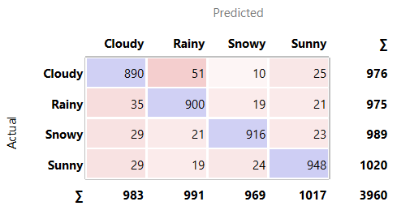

Experiment 2
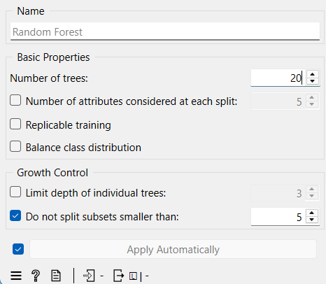
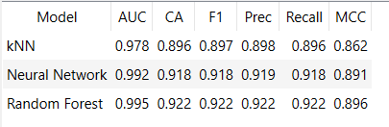
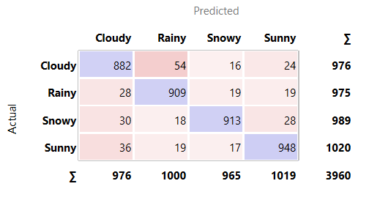

Experiment 3
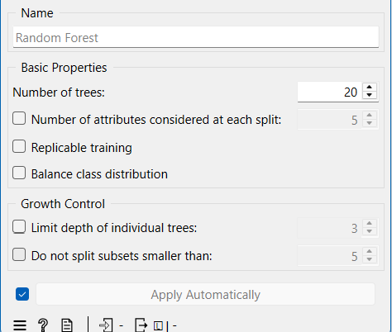

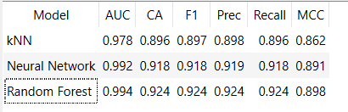
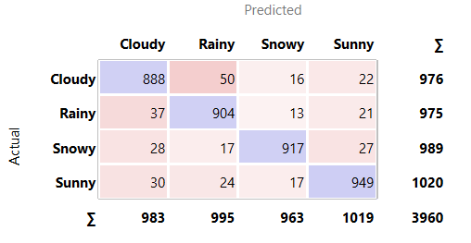

Conclusions from experiments:

The Random Forest experiments show that changing the number of trees and the split subset limit affects the model performance. In all experiments, the max depth was set to no limit, meaning that the trees were allowed to grow fully.
In Experiment 1, the model used 10 trees and a split subset limit of 5. It achieved CA = 0.923, F1 = 0.923, Precision = 0.923, Recall = 0.923, and MCC = 0.897. This result is already strong and better than the kNN and Neural Network models shown in the comparison table.
In Experiment 2, the number of trees was increased to 20, while the split subset limit stayed at 5. The model achieved CA = 0.922, F1 = 0.922, Precision = 0.922, Recall = 0.922, and MCC = 0.896. Its AUC value increased to 0.995, but the other main performance metrics were slightly lower than Experiment 1.
In Experiment 3, the model used 20 trees and the split subset limit was set to no limit. This experiment achieved the best overall Random Forest performance, with CA = 0.924, F1 = 0.924, Precision = 0.924, Recall = 0.924, and MCC = 0.898. The confusion matrix also shows strong correct classification values for all classes.
Overall, Experiment 3 performed the best among the Random Forest experiments. It achieved the highest CA, F1, Precision, Recall, and MCC values, while also keeping a very high AUC score.

Model selected for testing:
The model selected for testing is Random Forest Experiment 3.
Hyperparameter | Value
Number of trees | 20
Max depth | No limit
Split subset limit | No limit
Experiment 3 was selected because it achieved the best overall performance among the Random Forest models, especially in CA, F1, Precision, Recall, and MCC.

Testing results of the trained models
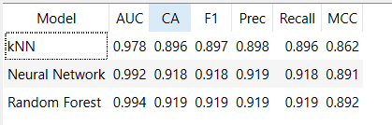

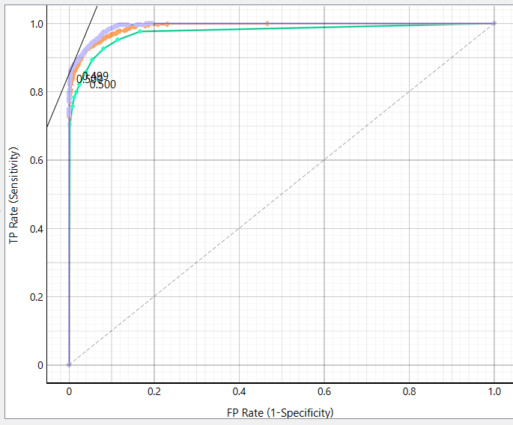

Conclusions after testing:

The testing results show that all three trained models performed well, but there are clear differences between their final performance values.

The kNN model achieved the lowest performance among the tested models, with CA = 0.896, F1 = 0.897, Precision = 0.898, Recall = 0.896, and MCC = 0.862. Although its performance is acceptable, it is weaker than the Neural Network and Random Forest models. This is because distance-based classification methods are more sensitive to overlapping class regions in the dataset.

The Artificial Neural Network model achieved strong classification performance, with CA = 0.918, F1 = 0.918, Precision = 0.919, Recall = 0.918, and MCC = 0.891. These results show that the Neural Network successfully classified the weather data and provided a strong balance between accuracy, precision, and recall.

The Random Forest model achieved the best overall performance, with CA = 0.919, F1 = 0.919, Precision = 0.919, Recall = 0.919, MCC = 0.892, and the highest AUC value of 0.994. The high AUC value indicates excellent class separation ability. Random Forest performed slightly better than the other models because ensemble learning combines multiple decision trees and reduces the risk of overfitting.

Overall, supervised learning algorithms achieved better results than the unsupervised clustering methods because the models were trained using known class labels. The results show that the selected weather features provide sufficient information for successful weather classification. Therefore, Random Forest can be considered the best final model for this classification task.

Information sources
1. Kaggle Dataset – Weather Type Classification:
https://www.kaggle.com/datasets/nikhil7280/weather-type-classification

2. Orange Data Mining:
https://orangedatamining.com/

3. OpenAI ChatGPT:
https://chatgpt.com/

4. Ortus Lecture Materials

Appendix
- https://chatgpt.com/share/69fb6edd-6294-8396-9e69-e7c87768bd8b
- https://chatgpt.com/share/69fb6f15-5a40-8384-b801-373d115b8153
- https://chatgpt.com/share/69fb6f44-b530-8396-98ce-41af82abcd1e

